**BANK LOAN REPORT QUERY DOCUMENT**

1. **BANK LOAN REPORT | SUMMARY**

**KPI’s:**

1. Total Loan Applications

select count(id) as Total_loan_apllication from Bank_loan

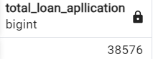

1. MTD loan application

select count(id) as total_Apllication from bank_loan

where EXTRACT(MONTH FROM issue_date) = 12;

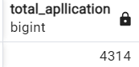

1. PMTD loan apllication

select count(id) as total_Apllication from bank_loan

where EXTRACT(MONTH FROM issue_date) = 11;  
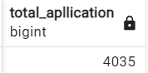

1. Total Funded Amount

select sum(loan_amount) as Total_Funded_Amount

from Bank_loan;

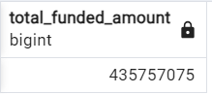

1. MTD Total Funded Amount

select sum(loan_amount) as Total_Funded_Amount

from Bank_loan

where extract(month from issue_date) = 12

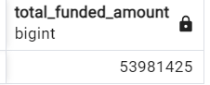

1. PMTD Total Funded Amount

select sum(loan_amount) as Total_Funded_Amount

from Bank_loan

where extract(month from issue_date) = 11

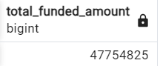

1. Total Amount Received

select sum(Total_payment) as total_amount_recived

from bank_loan

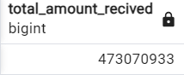

1. MTD Total Amount Received

select sum(total_payment) as MTD_total_Amount_received

from bank_loan

where extract(month from issue_date) = 12

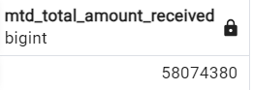

1. PMTD Total Amount Received

select sum(total_payment) as MTD_total_Amount_received

from bank_loan

where extract(month from issue_date) = 11

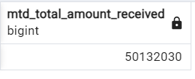

1. Average interest rate

select round(avg(int_rate),2)*100 as avgerage_interest_rate

from bank_loan

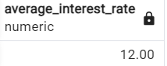

1. MTD Average interest rate

select round(avg(int_rate),2)*100 as MTD_average_interest_rate

from bank_loan

where extract(month from issue_date) = 12

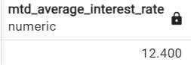

1. PMTD Average interest rate

select round(avg(int_rate),3)*100 as MTD_average_interest_rate

from bank_loan

where extract(month from issue_date) = 12

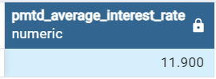

1. Average DTI

select round(avg(dti),2)*100 as Avg_DTI from bank_loan

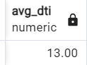

1. MTD Average DTI

select round(avg(dti),4)*100 as MTD_Avg_DTI from bank_loan

where extract(month from issue_date) = 12

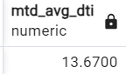

1. PMTD Average DTI

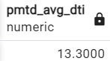

**GOOD LOAN ISSUED**

1. Good Loan Percentage

select (COUNT(CASE WHEN loan_status = 'Fully Paid' OR loan_status = 'Current' THEN id END) * 100)/COUNT(id) as good_loan_percentage

from bank_loan

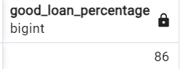

1. Good_Loan_application

select count(id) as good_laon_application from bank_loan

where loan_status = 'Fully Paid' or loan_status = 'Current'

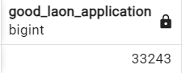

1. Good loan funded amount

select sum(loan_amount) as Good_Loan_Funded_Amount from bank_loan

where loan_status = 'Fully Paid' or loan_status = 'Current'

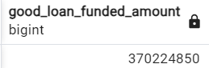

1. Good loan amount received

select sum(Total_payment) as Good_Loan_amount_received from Bank_loan

where loan_status = 'Fully Paid' or loan_status = 'Current'

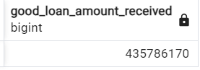

**BAD LOAN ISSUED**

1. Bad Loan Percentage

Bad Loan Percentage

select round((count

(case when loan_status ='Charged Off' then id end) * 100.0)/ count(id),2) as bad_Loan_percentage

from Bank_loan

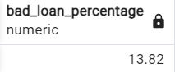

1. Bad Loan Application

select count(id) as Bad_Laon_Application from bank_loan

where loan_status = 'Charged Off'

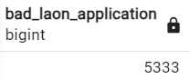

1. Bad Loan Funded Amount

select sum(loan_amount) as Bad_loan_funded_amount from Bank_loan

where loan_status = 'Charged Off'

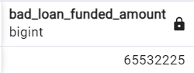

1. Bad Loan Amount Received

select sum(Total_Payment) as Bad_loan_amount_received from Bank_loan

where loan_status = 'Charged Off'

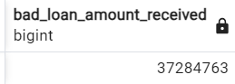

**LOAN STATUS**

1. Loan status

select loan_status,

count(id) as loan_count,

sum(total_payment) as Total_Amount_received,

sum(loan_amount) as total_funded_amount,

round(avg(int_rate),3) as intrest_rate,

round(avg(dti),2) as DTI

from bank_loan

group By loan_status

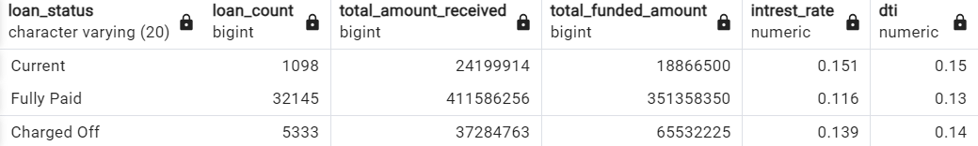

1. MTD loan status

select loan_status,

sum(total_payment) as MTD_total_payment,

sum(loan_amount) as MTD_total_funded_amount

from bank_loan

where extract(month from issue_date) = 12

group by loan_status

order by MTD_total_payment desc

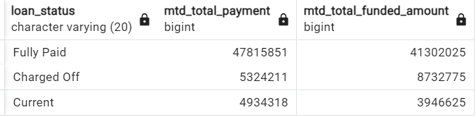

1. **BANK LOAN REPORT | OVERVIEW**
2. MONTH

SELECT

extract(month from issue_date) AS Month_Number,

to_char(issue_date, 'month') AS Month_name,

COUNT(id) AS Total_Loan_Applications,

SUM(loan_amount) AS Total_Funded_Amount,

SUM(total_payment) AS Total_Amount_Received

FROM bank_loan

GROUP BY extract(month from issue_date), To_char(issue_date, 'month')

ORDER BY extract(month from issue_date)

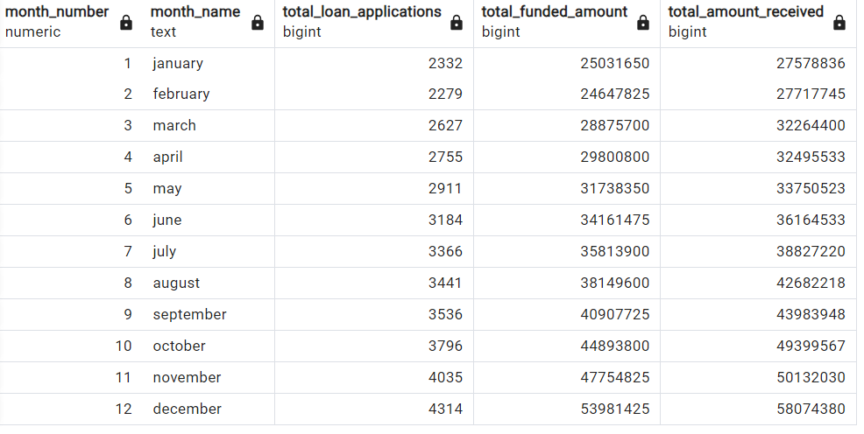

1. State

select address_state as state,

count(id) as total_loan_application,

sum(loan_Amount) as total_funded_amount,

sum(total_payment) as total_amount_received

from bank_loan

group by state

order by state

|  |  |  |  |
| --- | --- | --- | --- |
| state | total_loan_application | total_funded_amount | total_amount_received |
| AK | 78 | 1031800 | 1108570 |
| AL | 432 | 4949225 | 5492272 |
| AR | 236 | 2529700 | 2777875 |
| AZ | 833 | 9206000 | 10041986 |
| CA | 6894 | 78484125 | 83901234 |
| CO | 770 | 8976000 | 9845810 |
| CT | 730 | 8435575 | 9357612 |
| DC | 214 | 2652350 | 2921854 |
| DE | 110 | 1138100 | 1269136 |
| FL | 2773 | 30046125 | 31601905 |
| GA | 1355 | 15480325 | 16728040 |
| HI | 170 | 1850525 | 2080184 |
| IA | 5 | 56450 | 64482 |
| ID | 6 | 59750 | 65329 |
| IL | 1486 | 17124225 | 18875941 |
| IN | 9 | 86225 | 85521 |
| KS | 260 | 2872325 | 3247394 |
| KY | 320 | 3504100 | 3792530 |
| LA | 426 | 4498900 | 5001160 |
| MA | 1310 | 15051000 | 16676279 |
| MD | 1027 | 11911400 | 12985170 |
| ME | 3 | 9200 | 10808 |
| MI | 685 | 7829900 | 8543660 |
| MN | 592 | 6302600 | 6750746 |
| MO | 660 | 7151175 | 7692732 |
| MS | 19 | 139125 | 149342 |
| MT | 79 | 829525 | 892047 |
| NC | 759 | 8787575 | 9534813 |
| NE | 5 | 31700 | 24542 |
| NH | 161 | 1917900 | 2101386 |
| NJ | 1822 | 21657475 | 23425159 |
| NM | 183 | 1916775 | 2084485 |
| NV | 482 | 5307375 | 5451443 |
| NY | 3701 | 42077050 | 46108181 |
| OH | 1188 | 12991375 | 14330148 |
| OK | 293 | 3365725 | 3712649 |
| OR | 436 | 4720150 | 4966903 |
| PA | 1482 | 15826525 | 17462908 |
| RI | 196 | 1883025 | 2001774 |
| SC | 464 | 5080475 | 5462458 |
| SD | 63 | 606150 | 656514 |
| TN | 17 | 162175 | 141522 |
| TX | 2664 | 31236650 | 34392715 |
| UT | 252 | 2849225 | 2952412 |
| VA | 1375 | 15982650 | 17711443 |
| VT | 54 | 504100 | 534973 |
| WA | 805 | 8855525 | 9531739 |
| WI | 446 | 5070450 | 5485161 |
| WV | 167 | 1830525 | 1991936 |
| WY | 79 | 890750 | 1046050 |

1. TERM

select term as term,

count(id) as Total_Apllication,

sum(loan_amount) as Total_funded_loan_amount,

sum(total_payment) as Total_amount_Received

from bank_loan

group by term

order by term

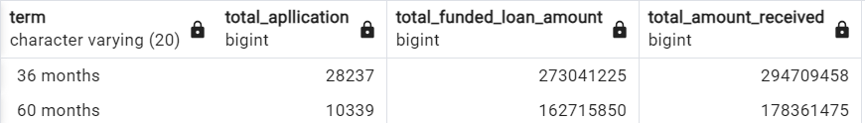

1. EMP_LENGTH

select emp_length as emp_length,

count(id) as total_loan_Apllication,

sum(loan_amount) as total_Funded_amount,

sum(total_payment) as total_Amount_Received

from bank_loan

group by emp_length

order by emp_length

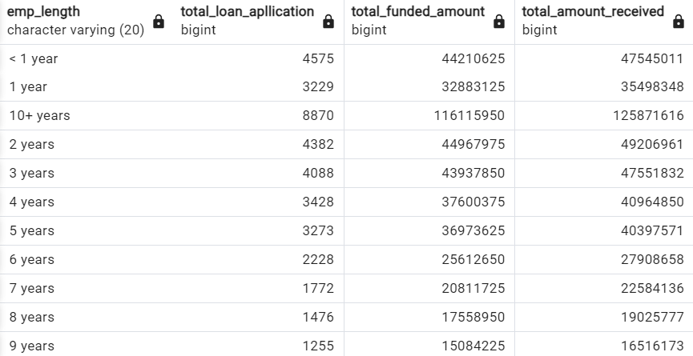

1. PURPOSE

select purpose as purpose,

count(id) as total_loan_Apllication,

sum(loan_amount) as total_Funded_amount,

sum(total_payment) as total_Amount_Received

from bank_loan

group by purpose

order by purpose

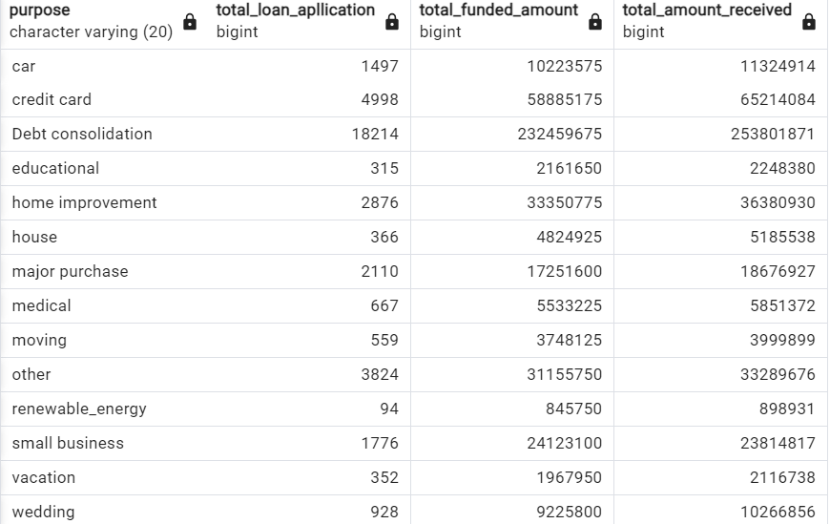

1. HOMEWONERSHIP

select home_ownership as home_ownership,

count(id) as total_loan_Apllication,

sum(loan_amount) as total_Funded_amount,

sum(total_payment) as total_Amount_Received

from bank_loan

group by home_ownership

order by home_ownership

